APPLICATION

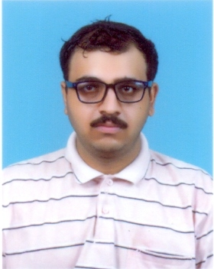
BIODATA OF RAMESWAR MISHRA

Name: MR. RAMESWAR MISHRA
Father’s Name: Mr. Kamala Kanta Mishra
Age: 29 years Date of birth: 29.11.1990
Present & Permanent Address: C/o Mr. K.K.Mishra
At Hanuman Colony Lane 1
Near Dist. Veterinary Office , Sakhipara
P.O./Dist.Sambalpur-768001(Odisha)
Contact No. 9439425882/9437088663
AADHAAR No. 315484627847
PAN No. BUHPM3075M
Landline: 0663-2548363
Employment Exchange, Sambalpur Regd.No.OD2812017743
Email Address: rameswarm35@gmail.com
Educational Qualification:
Sl | Standard / degree | Board /  University | Institute | Year of passing | Percentage | Maximum  Marks | Mark  Obtained
01 | MSc(IT) | Karnataka  State Open University | NIMT,Bhubaneswar | 2014 | 75 % | 1200 | 900
02 | BSc (IT) | Kuvempu  University | N I I T, Bhubaneswar | 2012 | 63.7% | 1950 | 1244
03 | GNIIT | N I I T | N I I T, Bhubaneswar | 2012 | 63.7% | 200 | 127.45
04 | 12th | CHSE | Jupiter +2 Science,  Sambalpur | 2008 | 51.6% | 600 | 310
05 | 10th | CBSE | Balika Vidyalaya,  Sambalpur | 2006 | 49.6% | 500 | 248

Skills: C++, .NET , HTML, C# ,Graphic design, Oracle (PL/SQL) – Certificates, Core JAVA
Software Projects done during study: HR-People Management by ADO.NET
At present doing Insurance business as SBI Life Agent/Advisor at Sambalpur
Experience: IT Faculty for 5 months at Tarabatidevi Institute of Professional Studies, Budharaja, Sambalpur
3 years at Reliance Education Complex, Balangir along with HR duties. Also acquainted
with Document Management System, Spreadsheets &, solving troubleshooting & other
Computer related problems. Imparted Computer training (at ITCT) at Sambalpur.
Hobby: Adobe Photo Editing, Cartoon making, 3D Animation, Body building, Listening Music, MS Office,
Making short Video clips

The above particulars are true to the best of my knowledge & belief. The related Certificates/ mark sheets will be produced at the required time for perusal.
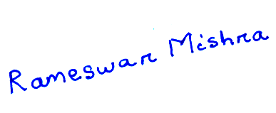
I assure, I would stand at your expectation if given a chance.

Date: 08.07.2020
SAMBALPUR (Rameswar Mishra)

